

Digital Bathymetric Model of Mono Lake, California

By Christian G. Raumann, Scott Stine, Alexander Evans¹, and Jerry Wilson

Miscellaneous Field Studies Map MF-2393

2002

Any use of trade, product, or firm names is for descriptive purposes only and does not imply endorsement by the U.S. Government.

U.S. Department of the Interior
U.S. Geological Survey

ABSTRACT
In 1986 and 1987, Pelagos Corporation of San Diego (now Racal Pelagos) undertook a bathymetric survey of Mono Lake in eastern California for the Los Angeles Department of Water and Power (DWP). The result of that survey was a series of maps at various scales and contour intervals. From these maps, the DWP hoped to predict consequences of the drop in lake level that resulted from their diversion of streams in the Mono Basin. No digital models, including shaded-relief and perspective-view renderings, were made from the data collected during the survey. With the permission of Pelagos Corporation and DWP, these data are used to produce a digital model of the floor of Mono Lake. The model was created using a geographic information system (GIS) to incorporate these data with new observations and measurements made in the field. This model should prove to be a valuable tool for enhanced visualization and analyses of the floor of Mono Lake.

INTRODUCTION
Mono Lake is a hydrographically closed saline lake located on the east side of the Sierra Nevada in central California (fig. 1). It is the remnant of Pleistocene Lake Russell and has fluctuated in level throughout the Late Quaternary, including historic times. At the June 2000 surface level of 6,384.5 ft (1,946.0 m) above sea level, the lake has an east-west dimension of 13.3 mi (21.4 km) and a north-south dimension of 9.3 mi (14.9 km). Numerous geologically young volcanic features are found in the Mono Basin, which include Paoha and Negit Islands and many small islets near the center of Mono Lake.
In 1941, the City of Los Angeles began diverting water from Mono Lake’s principle feeder streams for domestic use. After several years of experimentation, the lake level began to fall. Between 1947 and 1982, the lake’s surface

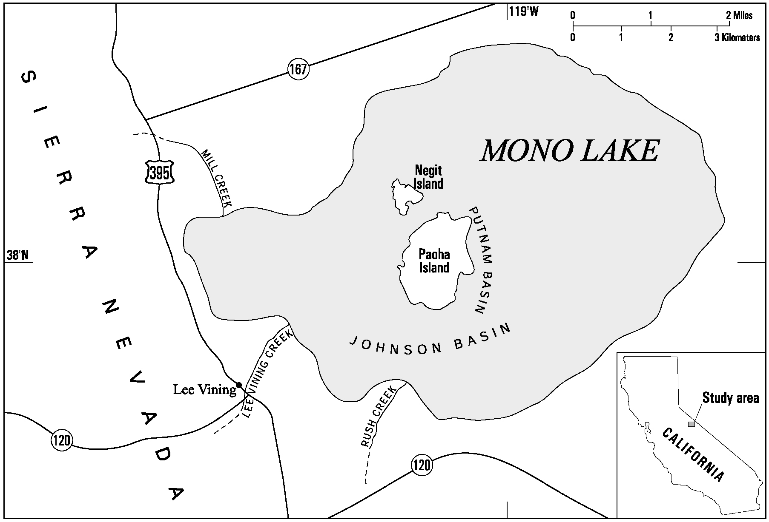
Figure 1. Map showing location of study area and Mono Lake and vicinity.

level dropped 44.9 ft (13.7 m). Following years of legal proceedings, the California State Water Resources Control Board in 1984 ordered Los Angeles to curtail diversions. Since then the lake has risen 11.2 ft (3.4 m) to an elevation of 6,384.5 ft (1,946.0 m) above sea level as of June 2000 (Los Angeles Aqueduct Daily Reports and Mono Lake Committee).
The purpose of this project is to produce a modern digital bathymetric model of the floor of Mono Lake. This model will be an evaluation tool that allows for better visualization and analyses to help understand the characteristics and origin of the bottom features of Mono Lake.

PREVIOUS WORK
Russell (1889) gave the first description of the floor of Mono Lake and briefly discussed bottom features in a monograph on the Mono Basin published by the U.S. Geological Survey (USGS). On the basis of approximately 100 soundings, he produced a map with 25-ft elevation contour intervals. He determined that the deepest part of the lake was along the southern border of Paoha Island at 152 ft (the lake stood at 6,410 ft at the time of Russell’s study (Stine, 1987, 1990)). He also stated that the average depth of the lake was between 60 to 62 ft (18.3 to 18.9 m) (Russell, 1889).
The Earth and Planetary Sciences Division of the U.S. Naval Ordnance Test Station performed a more detailed and thorough bathymetric study of Mono Lake in July 1964. The survey was conducted using a continuous-recording fathometer along approximately 200.1 mi (322 km) of sounding lines. Approximately 3,000 acoustic soundings were used to construct a bathymetric chart with 10-ft contour intervals. The resulting report described the major bathymetric features of Mono Lake (fig. 1; Scholl and others, 1967).
Scholl and others (1967) summarized their study in four key interpretations that they offered as provisional hypotheses to aid future work in the Mono Basin. First, most of the small- and large-scale bathymetric relief is Holocene and was not present beneath Pleistocene Lake Russell. Second, bottom relief is highest and most irregular in the vicinity of Paoha Island. Third, Paoha Island was formed by the intrusion of volcanic features from beneath the central part of Mono Lake, displacing lacustrine deposits that previously composed the lake floor. Fourth, a prominent subbottom reflector lies beneath lake muds over the central part of Johnson Basin to the south of Paoha Island (Scholl and others 1967).
Between August 1986 and February 1987, Pelagos Corporation of San Diego (now called Racal Pelagos and hereafter referred to as Pelagos) undertook a bathymetric survey of Mono Lake for the Los Angeles Department of Water and Power (DWP). According to the report produced be Pelagos for the DWP, “the purpose of the study was to gain additional knowledge on the lake’s bathymetry (the measurement of water depths), geology, and bottom features” (Pelagos, 1987). The result of that survey was a series of maps at various scales and contour intervals. Data from the Pelagos survey form the basis for the digital model developed here. The Pelagos survey is discussed in more detail below.
Recent bathymetric surveys of other lakes and coastal areas that have resulted in high-resolution digital models include a 1998 survey of Lake Tahoe conducted by the USGS in cooperation with the Ocean Mapping Group from the University of New Brunswick. This survey used a high-resolution multibeam mapping system that has replaced the acoustic methods used by Pelagos at Mono Lake as the standard for precision bathymetric surveys (Gardner and others, 1998). Nevertheless, the Pelagos data are sufficient to produce digital datasets and maps similar to those produced for Lake Tahoe as well as make possible similar bathymetric analysis.

THE PELAGOS SURVEY DATA AND MAPS
The survey data were collected along approximately 1,020 km (3345.6 ft) of sounding lines using two 24-ft boats, each equipped with an echo sounder, subbottom profiler (boomer-type system), sidescan sonar, and electronic navigation system. Water depths were measured by survey-grade echo sounders every 15 m (4.6 ft) along each survey line and were recorded onto floppy disk along with the position data. The digital data were transferred to a VAX-11/780 VMS mini-computer for editing and digitizing by a Science Accessories Model GP8 sonic digitizer. A total of 29,650 depth points were used to construct the bathymetric part of the topographic maps (Pelagos, 1987).

Horizontal and Vertical Accuracy
Horizontal positions were obtained using a Motorola Mini-Ranger III system, which has a manufacturer’s stated accuracy of ± 2 m (6.6 ft) for a calibrated system. Vessel positions during the survey were based on triangulation between three or more satellites, which allowed for an accuracy of 2 m (6.6 ft) or less. Furthermore, the Mini-Ranger antenna was mounted directly above the echo-sounder transducer to avoid any position-versus-depth offset error (Pelagos, 1987).
The Raytheon echo sounder used by Pelagos had a vertical accuracy of 0.06 m (0.2 ft), and their digitizing system had an accuracy of 0.08 m (0.3 ft). Their field calibration steps were designed to meet or exceed the manufacturer’s stated accuracy, bringing accuracy of depth measurements to ±0.15 m (0.5 ft) (Pelagos, 1987).
Boat motion during the survey, such as boat heave, squat, and roll, was likely a limiting factor on the depth accuracy of the survey (James Gardner, written commun., 2001). However, no mention was made concerning boat motion or its effect in the Pelagos report (Pelagos, 1987).

Combined Bathymetric and Topographic Maps
The final maps drafted by Pelagos show lakeshore topography combined with bathymetry covering elevations from 6,230 to 6,430 ft (1898.9 to 1959.9 m). These maps have scales of 1:24,000 and 1:12,000 with 5-ft contour intervals covering the entire lake, and 1:6,000 with 2-ft contour intervals for the regions around Paoha and Negit Islands. At the time of the survey, the surface level of the lake was 6,380.7 ft. Contours at and below 6,370 ft were mapped using the data acquired from the bathymetric survey, while contours 6,375 to 6,430 ft were mapped using photogrammetric techniques based on aerial photography from 1982 collected by Pacific Western Aerial Surveys (Pelagos, 1987).

DIGITAL MODEL PROCESS AND METHODS
The goal of this project was to produce a digital model of the bathymetry of Mono Lake by building upon and further processing the Pelagos data. The digital model was created by combining the Pelagos data with additional field measurements, along with other digital data obtained from the USGS, in a geographic information system (GIS).
A digital elevation model (DEM) is a raster-based dataset that uses a uniform grid system to depict elevations over a specified area of the Earth’s surface. Typically, large-scale DEMs are based on and referred to by a standard USGS 7.5-minute quadrangle, although DEMs are by no means limited to this geographic delineation. The primary task of the project was to construct a DEM of Mono Lake that accurately represents the lake’s bathymetry. This DEM could then be used to model and map the lake floor.

The Pelagos Dataset
Two 9-track tapes were received on loan from Pelagos. These tapes contained archived digital files of the survey, but the nature of the digital data was not clear. To extract the data from these tapes, a UNIX-based computer at the USGS in Menlo Park, Calif., that supports the VAX/VMS format was used. After extraction, the files were transferred to a CD-ROM. Approximately 240 files were analyzed and the 40 files essential to constructing the DEM were identified. These files were in a generic data (DAT) format.
When viewed in a spreadsheet application, the data are shown as points with horizontal and vertical California State Plane coordinates (North American Datum of 1927) with elevations in feet for each point. The number of points in each file varies from approximately 33 (for A3.dat) to 45,020 (for D4.dat) depending on the size of the area and the complexity of relief covered by the DAT file. Pelagos also supplied multiple printed maps of grids showing the geographic coverage of the DAT files. When combined into a single grid system, the data contained in the 40 DAT files cover the entire lake up to a surface elevation of 6,430 ft (fig. 2).
The points contained in the DAT files, when converted to DBF format and viewed as point coverages using ESRI’s ArcView GIS software, represent vertices of contour lines digitized by Pelagos at 5-ft elevation contour intervals (fig. 3). These files show that the original combined topographic and bathymetric maps produced by Pelagos were digitized and then the line information was saved as point data. The entire area covered by the original maps was then divided into the grid that is shown in figure 2. The average size for each of the grid cells is 10,000 by 10,000 ft (3,048.04 by 3,048.04 m).
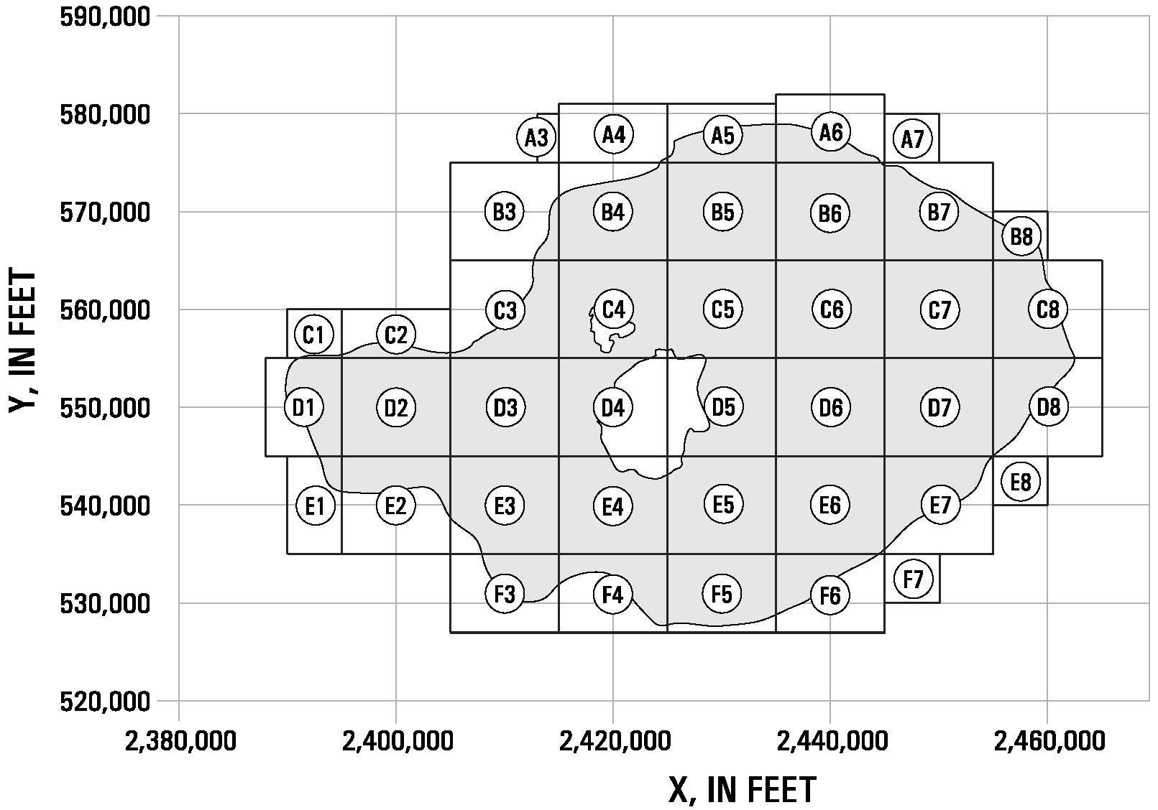
Figure 2. Location of digitized contour sections of Mono Lake (from Pelagos Corporation,1987) shown in California State Plane coordinates. Circled letter and number indicates DAT file designation.

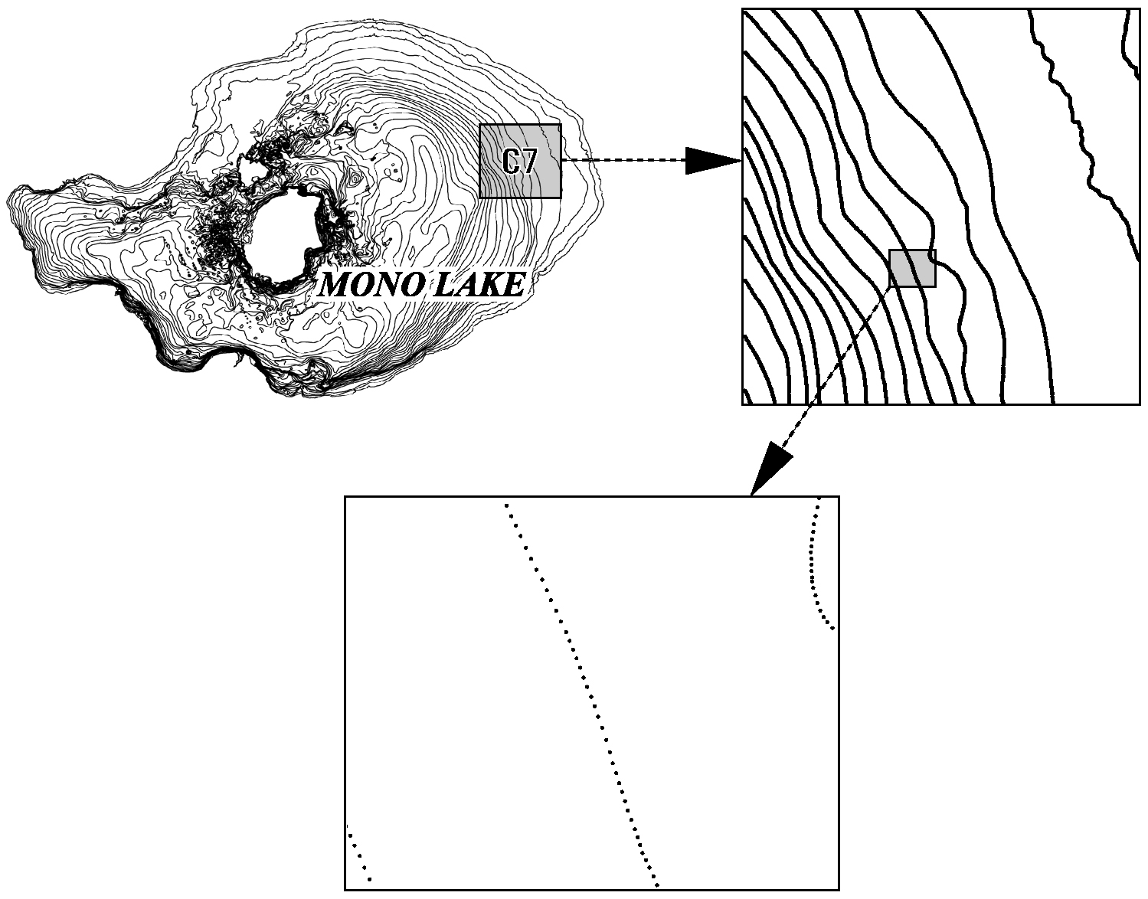
Figure 3. Location of contour section DAT file C7 and example of digitized line as point coverage contained in file.
Because the data supplied by Pelagos are in essence the digitized hand-drawn contours of the printed maps (although represented by points rather than lines) and not the actual 29,650 survey points, it was necessary to approach and process the data in a way that would not lessen or corrupt the integrity of the original data source (that is, the survey depth points). The accuracy of the final digital model relies upon the original cartographic work done by Pelagos and the data processing performed thereafter.

Data Processing
The first step was to construct a seamless vector coverage of the entire lake with lines (or arcs as they are referred to in ESRI’s ARC/INFO software package) representing contour lines at 5-ft intervals.
This process involved several steps. Initially, the points contained in each DAT file were converted into arcs. Next, all 40 coverages were combined to produce one coverage with elevation contours for the entire lake and immediate shoreline. At this point, it was apparent that significant editing was necessary to clean up the dataset and remove artifacts, especially along the seams where the arcs in each of the individual coverages shown in figure 2 join together.
In addition editing the bathymetric contours prior to DEM creation, some corrections were made to the Pelagos contours in the area containing numerous islets northeast of Negit Island (fig. 4). The original mapping in this area was inaccurate because of navigational hazards. Additional data collected in the field in 1989 were used to rectify the contours in this area; these changes are documented below.

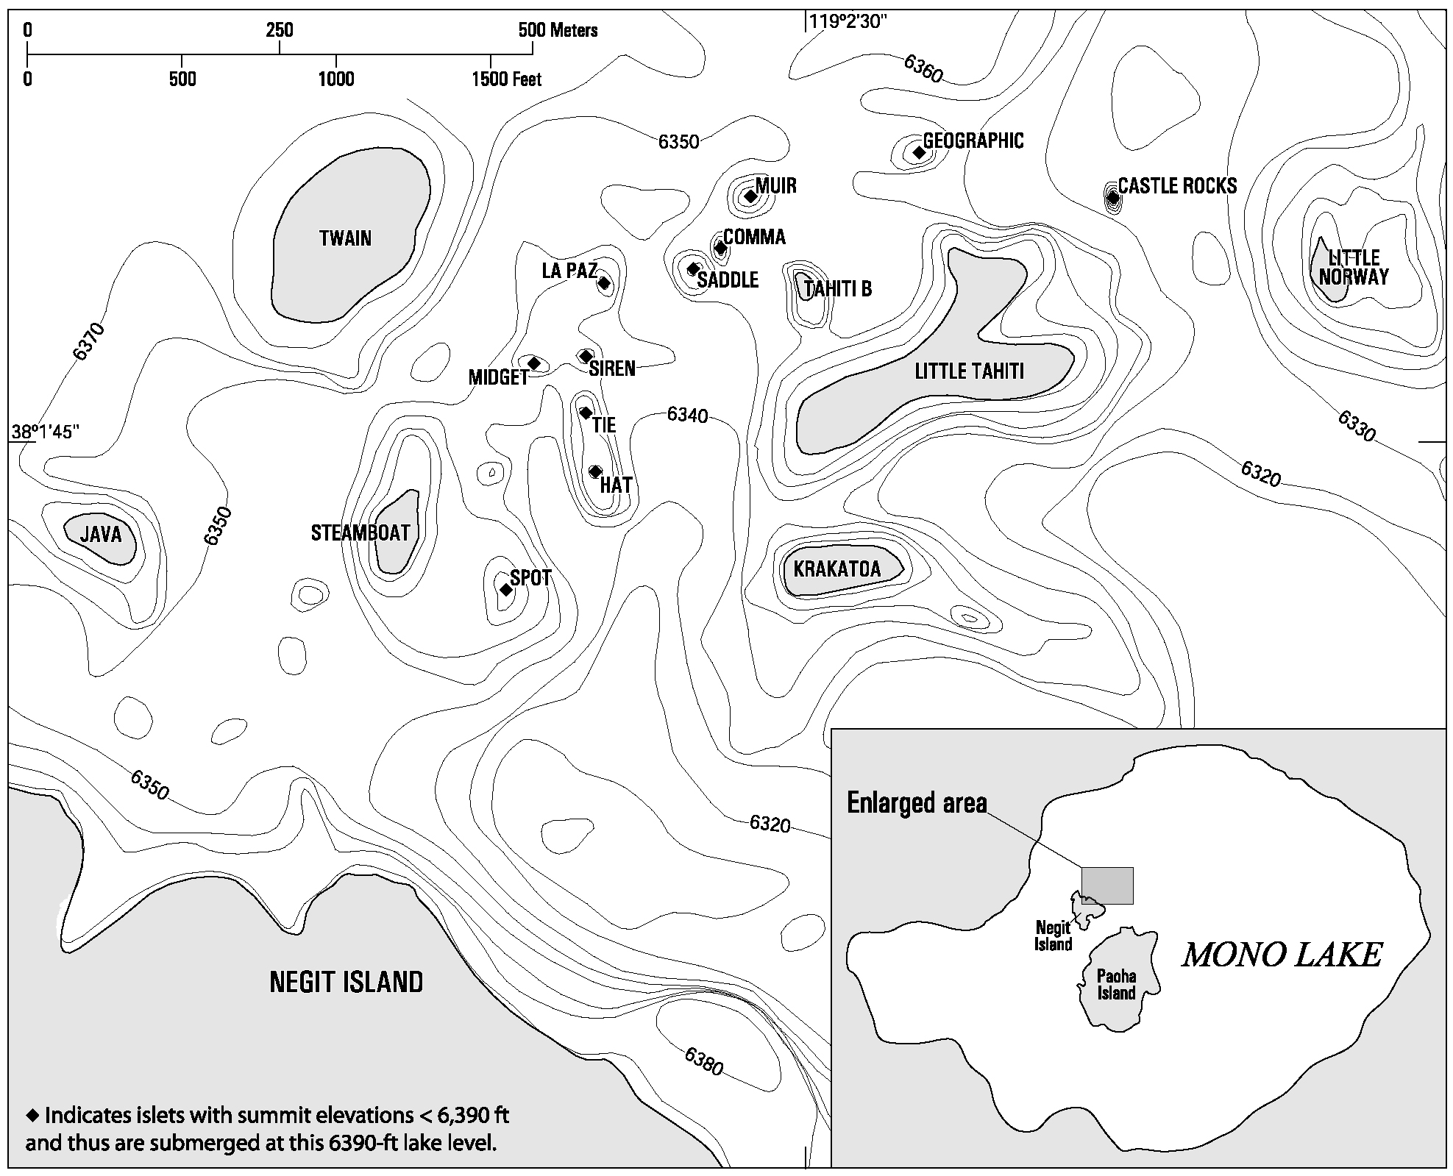
Figure 4. Map showing location of islets northeast of Negit Island. Bathymetric contour interval is 10 ft. Lake level 6,390 ft.

The next step was to construct a DEM using the seamless vector coverage created previously. The standard USGS large-scale DEM has either 10- or 30-m grid spacing, meaning that for each 10 by 10-m, or 30 by 30-m grid space on the ground there is one elevation assigned to this space. For this project, a 10-m grid spacing was used. No information was available regarding the techniques Pelagos used to convert their survey data points into contours, but after experimenting with different grid spacings, a 10-m spacing produced a relatively smooth grid without significant artifacts due to generation from contour lines. The command TOPOGRID in ARC/INFO, which is an interpolation method specifically designed for the creation of hydrologically correct DEMs, was used to produce the bathymetric grid. Additional discussion concerning the interpolation methods used in TOPOGRID is provided by Hutchinson and Dowling (1991).
Bathymetric measurements, or depths, in the digital model are represented in feet above sea level and not feet below the surface of the lake, which is reasonable because Mono Lake is a hydrographically closed lake characterized by fluctuating surface elevations. Lake bottom measurements represented as elevations will remain relatively unchanged as the lake surface rises or falls, unlike water depths (feet below the surface), which will vary for any point on the lake bottom depending on the surface elevation of the lake.

Lake Level Selection
The 6,390-ft contour was chosen as the lake level for the upper elevation limit of the DEM because this is the closest contour line to the target lake level elevation of 6,391 ft mandated by the California State Water Resources Control Board. Once this level is reached, DWP can then begin diverting water from streams feeding Mono Lake in substantial amounts. It is important to note, however, that the geomorphic processes that accompany a rising lake make it difficult to accurately predict where the 6,391-ft contour will be once the lake reaches this level.

Dataset Accuracy
Generating a grid from digitized hand-drawn contours for which documentation of vertical or horizontal accuracy regarding the contours is unavailable greatly complicates any evaluation of grid accuracy, making it difficult (if not impossible) to determine the accuracy for this digital bathymetric model of Mono Lake. Interpolation of the contours using various grid spacings only reflects the detail and accuracy of the original contouring, which is a very subjective process with accuracy being a reflection of the cartographer’s interpretation of the original data points.

CORRECTIONS TO BATHYMETRY
On the basis of fieldwork conducted in 1989 consisting of spot depth measurements made with a leadline from a 17-ft canoe and on analyses of aerial photos from 1930, ‘40, ‘56, ‘64, ‘72, ‘75, and ‘82, the following corrections were made to the bathymetry around the informally named islets northeast of Negit Island (table 1; fig. 4) (Stine, 1991). These corrections were then incorporated into the vector contour dataset prior to creation of the bathymetric grid.

MAPS

Sheet 1
This map incorporates shaded relief with full-spectrum color gradient for the bathymetry along with a grayscale shaded-relief image of the surrounding topography derived from USGS 30-m DEMs. The 20-ft bathymetric contour lines are from the vector coverage used to generate the bathymetric grid. Hydrographic and transportation vector data are from 1:24,000- and 1:100,000-scale USGS Digital Line Graphs.

Sheet 2
This map shows the viewing location and angles for 10 perspective views located at various points around Mono Lake. The perspective views show selected bathymetric and topographic features around Mono Lake at varying amounts of vertical exaggeration.

Table 1. Corrections made to bathymetry of Mono Lake northeast of Negit Island

Islet name* or area | Correction(s) to bathymetry⁺
Geographic | Raised summit contour from 6,370 to 6,380 ft.
Steamboat | Raised summit contour from 6,410 to 6,420 ft.
Little Norway | Raised summit contour from 6,400 to 6,420 ft.
Krakatoa | Raised summit contour from 6,410 to 6,420 ft.
Hat | Raised summit contour from 6,370 to 6,380 ft.
Tie | Raised summit contour from 6,375 to 6,390 ft.
Spot | Raised summit contour from 6,375 to 6,385 ft.
Twain | Raised summit contour from 6,410 to 6,420 ft.
Midget | Raised summit contour from 6,370 to 6,380 ft.
Siren | Raised summit contour from 6,370 to 6,380 ft.
LaPaz | Raised summit contour from 6,370 to 6,380 ft.
Java | Raised summit contour from 6,400 to 6,415 ft.
Little Tahiti | Raised the contours of the four principle summits of Little Tahiti from (variously) 6,380-6,415 ft to 6,420 ft.
Castle Rocks | Added contours (to a summit contour of 6,380 ft) to reflect the presence of Castle Rocks, an islet absent from the Pelagos bathymetry.
Area north of Geographic | Presence of the gentle rise from 6,360 ft to 6,370 ft that was mapped by Pelagos immediately to the north of Geographic cannot be confirmed; therefore, this rise was removed.
Area northwest of Little Tahiti | Removed large submerged shelf northwest of islet and modified lake bottom in this area as follows:  1. Enclosed contours in far western part to reflect presence of Saddle,  the summit contour of which was raised from 6,370 to 6,380 ft.  2. Enclosed the contours immediately northeast of Saddle to reflect the  presence of Comma, the summit contour of which was raised from  6,375 to 6,380 ft.  3. Enclosed the contours immediately northeast of Saddle to reflect the  presence of Comma, the summit contour of which was raised from  6,375 to 6,380 ft.  4. Drew contours (to a summit contour of 6,380 ft) to reflect the  presence of Muir, which was absent from the Pelagos bathymetry.  5. The bathymetry that actually exists in the area to the north of Little  Tahiti, where Pelagos erroneously drew the broad, submerged shelf,  remains unknown.
*Names of islets are informal (Stine, 1991).
⁺1 ft = 0.3048 m.

ACKNOWLEDGMENTS
We would like to thank Peter Dartnell, John Vogel, Sean Stone, and Robert Lugo for their support, contributions, and assistance with this project.

REFERENCES CITED
Gardner, J.V., and Dartnell, P., 1999, Bathymetry and selected perspective views of Lake Tahoe, California and Nevada: U.S. Geological Survey Water Resources Investigation Report 99-4043.

Gardner, J.V., Mayer, L.A., and Hughes-Clarke, J., 1998, The bathymetry of Lake Tahoe, California-Nevada: U.S. Geological Survey Open-File Report 98-509.

Hutchinson, M.F. and Dowling, T.I., 1991, A continental hydrological assessment of a new grid-based digital elevation model of Australia: Hydrological Processes, v. 5, p. 45-58.

Los Angeles Aqueduct Daily Reports and Mono Lake Committee, Monthly Mono Lake Levels 1979-2000, accessed June 2000, at URL http://www.monolake.org/library/lakelevel/monthly.htm

Pelagos Corporation, 1987, A bathymetric and geologic survey of Mono Lake, California: San Diego, Calif., project report.

Russell, I.C., 1889, Quaternary history of the Mono Valley, California: U.S. Geological Survey Annual Report 8, pt. 1, p. 261-394.

Scholl, D.W., Von Huene, R., St. Amand, P., and Ridlon, J.B., 1967, Age and origin of topography beneath Mono Lake, a remnant Pleistocene lake, California: Geological Society of America Bulletin, v. 78, p. 583-600.

Stine, S., 1987, Mono Lake: the past 4,000 Years: University of California, Berkeley, Ph.D. dissertation, 615 p.

Stine, S., 1990, Late Holocene fluctuations of Mono Lake, eastern California: Palaeogeography, Palaeoclimatology, Palaeoecology, v. 78, p. 333-381.

Stine, S., 1991, Geomorphic, geographic, and hydrographic basis for resolving the Mono Lake controversy: Environmental Geology and Water Science, v. 17, n. 2, pp. 67-83.

U.S. Geological Survey, Menlo Park, California
California State University Hayward, Dept. of Geography and Environmental Studies
Racal Pelagos Corporation, San Diego, California

